SJIB Circular 02/2020

28 February 2020

To all SELECT and SJIB Members

Dear Sir/Madam,

National Minimum Wage (NMW)

and National Living Wage (NLW) Rates

The Government has announced that the National Minimum Wage (NMW) rates will increase on 1 April 2020.

- Employees aged between 21 and 24 years - £8.20 per hour.
- Employees aged between 18 and 20 years - £6.45 per hour.
- Employees aged between 16 and 17 years - £4.55 per hour.
- Apprentices under 19 years, or over 19 years if they are in the first year of their apprenticeship, should receive a NMW payment of £4.15 per hour. Please note, the SJIB has agreed contractual rates which Apprentices should be paid.
- Employees aged 25 and over must receive at least the National Living Wage payment of £8.72 per hour.

For Operatives, Apprentices and Adult Trainees who are paid in accordance with the SJIB National Working Rules, there is no need to take any action. However, Stage 2 Apprentices who are between 21 and 24 should be paid in accordance with the NMW. Stage 2 Apprentices who are over 25 should be paid the National Living Wage. The current SJIB rates of pay can be viewed at www.sjib.org.uk.

If you employ staff under other terms and conditions, you should ensure that the hourly rates meet the minimum rates.

Members wishing further information should contact the SJIB on 0131 445 9216 or email fiona.cornwall@sjib.org.uk .

Yours faithfully,

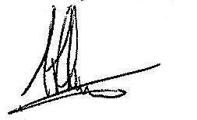
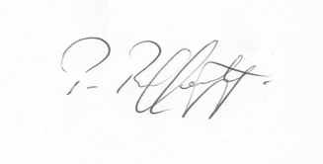
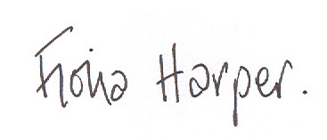

Fiona Harper Pat Rafferty Alick Smith
The Secretary For UNITE the Union For SELECT

