SJIB Circular 02/2021
26 March 2021

To all SELECT and SJIB Members

Dear Sir/Madam,

Changes to the ECS Health, Safety and Environmental Assessment
Effective Monday, 5 April 2021

The Independent Review of Building Regulations and Fire Safety was announced by government in July 2017 following the Grenfell Tower tragedy.
Its purpose was to make recommendations that will ensure:
- a sufficiently robust regulatory system for the future
- residents feel that the buildings they live in are safe and remain so
It examined building and fire safety regulations and related compliance and enforcement with the focus on multi-occupancy high-rise residential buildings.
The Review on Competence, Raising the Bar – Interim Report on Improving Competence and Building a Safer Future contained 67 recommendations.
As a result of these recommendations the ECS Steering Committee recently reviewed the Fire and Emergency questions within the ECS Health, Safety and Environmental Assessment and have developed new ones which focus on Fire Safety and Escape Routes and Safety at Work.
Previously, Candidates were asked to answer four questions from this section, this will increase to nine. The pass mark will change to 43, and there is no change to the time Candidates are allocated, which remains 30 minutes.
 | Current Format | New Format – from 5 April 2021
Total questions in Assessment | 45 | 50
Fire and Emergency questions | 4 | 9
Assessment Pass Mark | 38 | 43
Time Limit | 30 minutes | 30 minutes

Visit www.sjib.org.uk to access the new ECS Health, Safety and Environmental Question and Answer Booklet.

Yours faithfully,

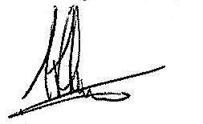
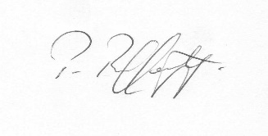
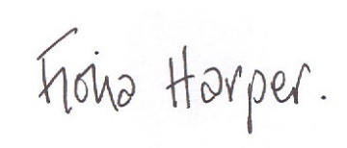
Fiona Harper  The Secretary | Pat Rafferty  For UNITE the Union | Alick Smith  For SELECT

