SJIB Circular 03/2021
26 March 2021

To: All SJIB and SELECT Members

Dear Sir/Madam,

Christmas 2021 and New Year 2022 Public Holidays

The SJIB National Board agreed, at a meeting on 10 March 2021, that the three days of Public Holiday for the Christmas 2021 and New Year 2022 period are:

Monday | 27 December 2021
Tuesday | 28 December 2021
Monday | 3 January 2022

Employees required to work during this holiday period are to be paid as follows:

27 December 2021 | Double time (at the appropriate hourly rate) plus an alternative day of holiday to be mutually agreed.
28 December 2021 | Time plus one half of the appropriate hourly rate plus an alternative day of holiday to be mutually agreed.
3 January 2022 | Time plus one half of the appropriate hourly rate plus an alternative day of holiday to be mutually agreed.
All other days of holiday during this period which are worked are to be paid at the appropriate hourly rate.

Yours faithfully,

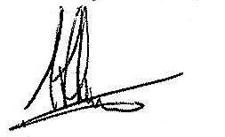
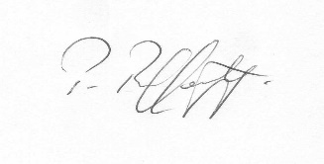
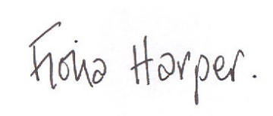
Fiona Harper  The Secretary | Pat Rafferty  For UNITE the Union | Alick Smith  For SELECT

