SJIB Circular 06/2021
26 March 2021

To: All SJIB and SELECT Members

Dear Sir/Madam,

Budget 2021 - Coronavirus Job Retention Scheme - NWR Relaxations

Since the beginning of the pandemic, the SJIB National Board has agreed a number of temporary relaxations to the SJIB National Working Rules in order to protect operatives and public safety and, at the same time support businesses to stay viable, and keep people in employment, thus avoiding redundancies.

In light of the Chancellor’s Budget statement of 3 March 2021 in which it was announced that the Coronavirus Job Retention Scheme (CJRS) would be extended until the end of September 2021, the SJIB National Board has agreed to continue the relaxation of:

- SJIB NWR B10.1, to allow SJIB employers and employees to agree full-time or flexible furlough arrangements, in line with CJRS requirements;
- SJIB NWR E3.3, to enable SELECT and SJIB Members who are not currently members of the SJIB Welfare Credit Scheme to join, thereby ensuring that their employees will be covered for welfare benefits (subject to the rules and provisions described in Section E of the SJIB Handbook) without the requirement of having to purchase a minimum of eight consecutive credits prior to the date of an employee's incapacity;
- SJIB NWR B35, so that employers and employees may agree to the latter working for a third party whilst on furlough.

This position will be reviewed again by the SJIB National Board on 8 October 2021

Please note that the UK Government, through HMRC, and SELECT have published full details on the provisions of the Budget 2021 and its impact on the CJRS.

Yours faithfully,
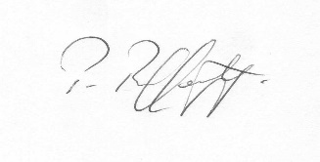
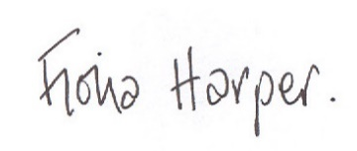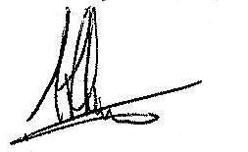
Fiona Harper Pat Rafferty Alick Smith
The Secretary For UNITE the Union For SELECT

