SJIB Circular 03/2020

11 June 2020

To all SELECT and SJIB Members

Dear Sir/Madam,
SJIB National Board Statement
Coronavirus (COVID-19)

Coronavirus is affecting all our daily lives including our workplaces. The SJIB recognises the very challenging position that employers and employees are now facing.

The Scottish electrical contracting industry is built on the principle of shared endeavour between employees, the union and employers and this approach will help us get through the current health and economic crisis.

The health and wellbeing of the workforce has been a priority of the SJIB for over 50 years and in these exceptional times it is more important than ever that the parties to the SJIB - SELECT and Unite the Union - work together in the interest of the electrical contracting industry, to get through the next few months.

The Scottish Government advice for business and workplaces is that “employees should be encouraged to work at home, wherever possible. Where that is not possible the recommendation is that non-essential workplaces should close”.

The SJIB National Board has worked hard to find the best decision in the context of this guidance to preserve the National Working Rules. The parties have striven to reach the right decision which will protect operatives and public safety and, at the same time support businesses to stay viable, and keep people in employment, thus avoiding redundancies.

SJIB National Working Rule B10.1 states that "the standard working week shall be 37.5 hours" and this is viewed as a cornerstone of the SJIB National Working Rules. However, this current situation has meant that many employers are unable to provide work.

With this in mind, the SJIB National Board has agreed, for a temporary period, to relax the provisions Rule B10.1 in order to help employers to avoid redundancy situations and to enable employers and employees to agree alternative arrangements in line with the Coronavirus Job Retention Scheme, announced by the UK Government on Friday 20 March 2020. This position will be reviewed again by the SJIB National Board on 9 October 2020.
The UK Government and HMRC have yet to publish full details about how the Coronavirus Job Retention Scheme will work in practice. Further SJIB notifications will be issued as and when these details become available.

In the meantime, the SJIB National Board encourages employers to make use of the Coronavirus Job Retention Scheme and to enter into discussions with their employees as soon as possible.

Yours faithfully,
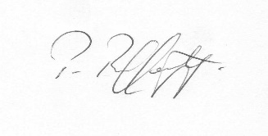
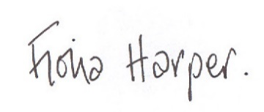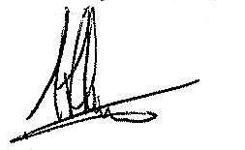

Fiona Harper Pat Rafferty Alick Smith
Secretary For UNITE the Union For SELECT

