SJIB Circular 05/2020
25 September 2020

To all SELECT and SJIB Members

Dear Sir/Madam,

Change to the Apprentice & Adult Trainee Grading Procedure

As a consequence of COVID-19 and subsequent college closures in March, Apprentices and Adult Trainees were not able to attend college and were, therefore, unable to complete the current stage of their apprenticeship.

Throughout the Lockdown, SECTT worked with the colleges and the Apprentices/Adult Trainees to introduce distance/on-line learning which it is hoped will reduce the time required to physically attend the college premises now that they are re-opening.

In addition, SECTT have worked hard to ensure that the appropriate interventions are put in place to ensure Apprentices/Adult Trainees can return safely to the colleges. These measures include a limit to class sizes which, in turn, means that Apprentices/ Adult Trainees are not able to complete their training and progress to the next Stage all together and at the one time.

As you are aware, the SJIB normally operates four milestone grading dates throughout the year. The SJIB National Board recently approved a new temporary Grading Timetable to ease flow and completion.

The new Grading Dates for this last quarter in 2020 are:
- 3rd Monday in September (21 September)
- 3rd Monday in October (19 October)
- 3rd Monday in November (16 November)
- 3rd Monday in December (21 December)

These additional dates will enable the up-grading of Apprentices/Adult Trainees at the first available opportunity following completion of the required coursework and experience.

Members wishing further information should contact the SJIB at the Walled Garden on 0131 445 9216 or email fiona.cornwall@sjib.org.uk.

Yours faithfully,
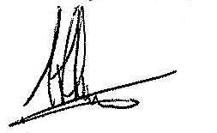
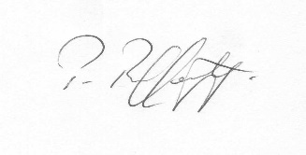
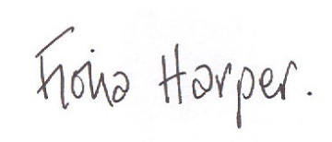
Fiona Harper  The Secretary | Pat Rafferty  For UNITE the Union | Alick Smith  For SELECT

