SJIB Circular 07/2020
25 September 2020

To all SELECT and SJIB Members

Dear Sir/Madam,

De-Registration of Apprentices and Adult Trainees

As you will be aware, the SJIB normally operates four milestone grading dates throughout the year. However, as a result of the COVID-19 Pandemic, and in order to ease flow and progression, the SJIB has agreed to implement four Grading Dates between September and December 2020 (please see SJIB Circular 05/2020).

There are conditions of service set out in the SJIB Apprentice and Adult Trainee Schemes Guide (Section J of the SJIB Handbook) which must be met.

Employers will be advised when Apprentices/Adult Trainees have:

- successfully completed the appropriate First Stage Competencies and satisfactorily completed the OneFile ePortfolio within 18 months of the commencement of their apprenticeship and, that they should be paid the Stage 2 wage rate.
- successfully completed the appropriate Second Stage Competencies and satisfactorily completed the OneFile ePortfolio within three years of the commencement of their apprenticeship and, that they should be paid the Stage 3 wage rate.
- successfully completed the appropriate Third Stage Competencies and, that they should be paid the Stage 3 FICA wage rate.

The SJIB will advise employers of any failures to achieve the required standards in any of the afore-mentioned stages in December this year. These Apprentices/Adult Trainees should remain on their current stage wage rate.

This letter will also provide employers with an opportunity to discuss any short falls, failure to complete the OneFile ePortfolio, appropriate competencies etc. with their Apprentice/Adult Trainee.

If there continues to be little or no progress the SJIB will issue a second letter advising employers that their Apprentice has failed to complete the:

- First Stage in 18 months and, that they may be removed from the SJIB Register of Apprentices and that employment may be terminated. J22.1(d).
- Second Stage in three years of the commencement of the apprenticeship and that they may be removed from the SJIB Register of Apprentices and, that employment may be terminated. J22.2(c).
- Third Stage in five years of the commencement of the apprenticeship and that they may be removed from the SJIB Register of Apprentices and, that employment may be terminated. J22.3(g).

For Adult Trainees - if there is little or no progress - employers will receive a letter advising them that their Adult Trainee has failed to complete the:

- First Stage in 18 months of the commencement of the adult traineeship and, that they may be removed from the SJIB Register of Adult Trainees and returned to their previous graded status. J23.1(d).
- Second Stage in three years of the commencement of the adult traineeship and, that they may be removed from the SJIB Register of Adult Trainees and returned to their previous graded status. J23.2(c).
- Third Stage in five years of the commencement of the adult traineeship and that they may be removed from the SJIB Register of Adult Trainees and returned to their previous graded status. J23.3(d).

As always, if there are mitigating reasons why an Apprentice or Adult Trainee has failed to meet the requirements, employers can apply for an extension by completing the Request for Extension Form which will be enclosed with the letter.

Members wishing further information should contact the SJIB at the Walled Garden on 0131 445 9216 or email fiona.cornwall@sjib.org.uk.

Yours faithfully,

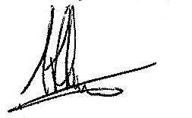
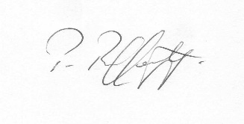
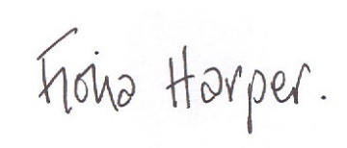
Fiona Harper  The Secretary | Pat Rafferty  For UNITE the Union | Alick Smith  For SELECT

