SJIB Circular 09/2020
30 October 2020

To all SELECT and SJIB Members

Dear Sir/Madam,

SJIB Lodging Allowance & Retention Fee Increases to Allowances
Effective Monday, 4 January 2021

The Lodging Allowance is based upon a formula which tracks the movement in the catering element of the Consumer Price Index. At its meeting on 9 October 2020, the SJIB National Board endorsed an increase in accordance with this formula from £41.70 to £42.28 per night. The Lodging Retention Fee will increase to up to a maximum of £13.91 per night. The Weekend Retention Fee will increase to £42.28 per night.

These rates are effective Monday, 4 January 2021.

Lodging allowance is paid to an employee who, by arrangement with his employer, has to take lodgings, and shall be payable in respect of each night spent away from home.

Lodging allowance shall not apply where suitable board and lodging is arranged by the employer at no cost to the employee.

For more guidance please refer to the Rates, Allowances and Benefits table for 2021 available on www.sjib.org.uk or email fiona.cornwall@select.org.uk

Yours faithfully,

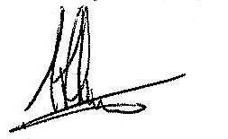
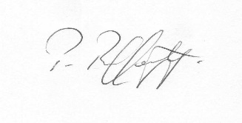
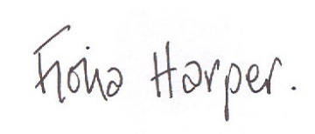
Fiona Harper  The Secretary | Pat Rafferty  For UNITE the Union | Alick Smith  For SELECT

