SJIB Circular 10/2020
30 October 2020

To all SELECT and SJIB Members

Dear Sir/Madam,
SJIB NWR 10.1
JOB SUPPORT SCHEME

As Coronavirus continues to affect all aspects of our daily lives including our workplaces, the SJIB recognises the very challenging circumstances facing employers and employees.

The advice and guidance from the Scottish and UK Governments has changed over the last few months and the majority of people are back at work. Indeed, the Scottish Government has recently reported that, whilst economic output remains 10.7% lower than pre-pandemic levels, the Scottish economy grew for a third consecutive month in July and recovered more than half the fall in output recorded in March and April. However, the Government has also stated that the path to recovery is fragile and that it is anticipating greater uncertainty for the fourth quarter due to the risk of a second wave and the re-introduction of further restrictions to business and household activities aimed at managing and reducing the spread of the virus.

Throughout the pandemic, the SJIB National Board has worked hard to find the best decisions in the context of government guidance to preserve the National Working Rules. The parties have striven to reach the right decisions to protect operatives and public safety and, at the same time support businesses to stay viable, and keep people in employment, thus avoiding redundancies.

SJIB National Working Rule B10.1 states that "the standard working week shall be 37.5 hours" and this is viewed as a cornerstone of the SJIB National Working Rules. However, as the pandemic has meant that many businesses are unable to operate at full capacity, the SJIB agreed, in March 2020, to relax the provisions of Rule B10.1 in order to help employers to avoid redundancy situations and to enable employers and employees to agree alternative arrangements in line with the Coronavirus Job Retention Scheme (Furlough).

We have been aware for some time that the Job Retention Scheme would close at the end of October and it was welcome news when the UK Government announced, on 24 September 2020, that the Job Support Scheme, which has been “designed to protect viable jobs in businesses who are facing lower demand over the winter months due to COVID-19 and to help keep employees attached to the workforce”, would be introduced on 1 November 2020 for a period of 6 months.

And so, the SJIB National Board has agreed, once again, to relax the provisions of Rule B10.1 in order to help businesses to avoid redundancy situations and to enable employers and employees to agree alternative arrangements in line with the Job Support Scheme. This position will be reviewed again by the SJIB National Board on 10 March 2021.

The UK Government and HMRC have yet to publish full details about how the Job Support Scheme will work in practice. Further notifications will be issued by SELECT as and when these details become available.

In the meantime, the SJIB National Board encourages employers and employees to make use of the Job Support Scheme where appropriate.

Yours faithfully,
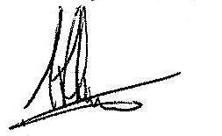
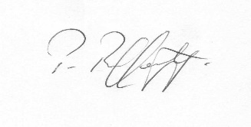
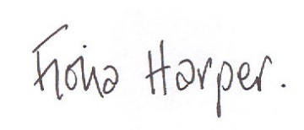
Fiona Harper  The Secretary | Pat Rafferty  For UNITE the Union | Alick Smith  For SELECT

