SJIB Circular 11/2020
27 November 2020

To all SELECT and SJIB Members

Dear Sir/Madam,

EXTENSION OF THE CORONAVIRUS JOB RETENTION SCHEME

Temporary relaxations to the SJIB National Working Rules were agreed in March 2020 and further extended in June so that they would remain in place until the Coronavirus Job Retention Scheme (CJRS) ceased on 31 October.

On 5 November, however, the UK Government announced that the CJRS was to be extended until 31 March 2021.

The SJIB National Board has, therefore, agreed to the continuation of the temporary relaxations until 31 March 2021.

The temporary relaxations relate to: -

- The relaxation to SJIB Rule B10.1 to enable employers and employees to agree alternative working arrangements in line with the Coronavirus Job Retention Scheme requirements.
- The relaxation of SJIB Rule B35, so that employers and employees may agree to the latter working for a third party whilst on furlough.
- The relaxation of SJIB NWR E3.3 to enable employer members to ensure Welfare Benefits cover is available for their Operatives without having to wait eight weeks to make a claim.

The Job Support Scheme, which was due to start on 1 November 2020, has been postponed, and the Job Retention Bonus Scheme will no longer be paid in February 2021. The Government has indicated that an alternative retention initiative to replace the Job Retention Bonus Scheme will be deployed at the appropriate time.

The SJIB will continue to monitor the situation and act accordingly. Further guidance will be placed on the www.select.org.uk as and when it becomes available.

Yours faithfully,
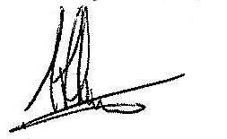
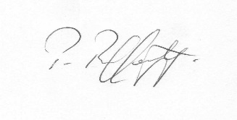
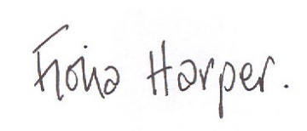
Fiona Harper  The Secretary | Pat Rafferty  For UNITE the Union | Alick Smith  For SELECT

