SJIB Circular 07/2021
30 April 2021

To: All SJIB and SELECT Members

Dear Sir/Madam,

National Minimum Wage (NMW) and National Living Wage (NLW) Rates

The Government has announced that the National Minimum Wage (NMW) rates will increase on 1 April 2021. In addition, the age at which the National Living Wage (NLW) becomes payable has been lowered to 23.

Age | Pay per hour
23 and over | £8.91 (NLW)
21 to 22 | £8.36
18 to 20 | £6.56
16 to 17 | £4.62
Apprentice | £4.30

The SJIB has agreed contractual rates which Electrical Installation Apprentices should be paid. The current SJIB rates of pay can be viewed at www.sjib.org.uk.

Apprentices under 19 years, or over 19 years if they are in the first year of their apprenticeship, should receive a NMW payment of £4.30 per hour.

For Operatives, Apprentices and Adult Trainees who are paid in accordance with the SJIB National Working Rules, there is no need to take any action. However, Stage 2 Apprentices who are aged between 21 and 22 should be paid in accordance with the NMW rates above. Stage 2 Apprentices who are aged 23 and over should be paid the National Living Wage.

If you employ staff under other terms and conditions, you should ensure that the hourly rates meet the minimum rates.

Members wishing further information should contact the SJIB on 0131 445 9216 or email fiona.cornwall@sjib.org.uk.

Yours faithfully,
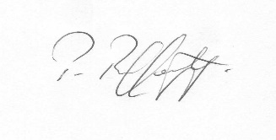
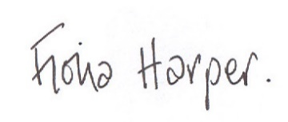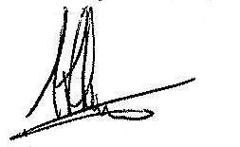
Fiona Harper Pat Rafferty Alick Smith
The Secretary For UNITE the Union For SELECT

