SJIB Circular 08/2021
30 April 2021

To: All SJIB and SELECT Members

Dear Sir/Madam,

Increase to Statutory Payments

Every year the Government announces various changes to statutory payments. The changes scheduled to take place in 2021 are listed below.

From 4 April 2021: -

- Statutory Maternity Pay, Statutory Paternity Pay, Statutory Adoption Pay and Statutory Shared Parental Pay for weeks 7 to 39 will increase from £151.20 to £151.97 per week.
- Statutory Parental Bereavement Pay will increase from £151.20 to £151.97 per week.
- Statutory Sick Pay will increase from £95.85 to £96.35 per week.

The cap on Statutory Redundancy Pay will increase from £538.00 to £544.00 per week on 6 April 2021.

Members wishing further information should contact the SJIB on 0131 445 9216 or email fiona.cornwall@sjib.org.uk.

Yours faithfully,
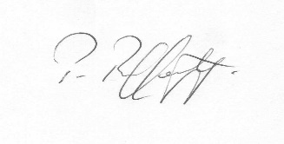
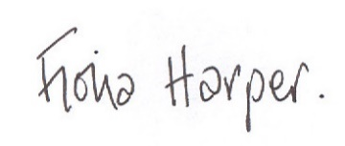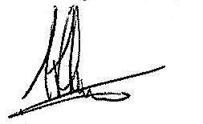
Fiona Harper Pat Rafferty Alick Smith
The Secretary For UNITE the Union For SELECT

