SJIB Circular 11/2021
25 June 2021

To all SJIB and SELECT Members

Dear Sir/Madam,

New Academically Qualified Person (AQP) ECS Card

We are pleased to announce that the SJIB is introducing a new Academically Qualified Person (AQP) card at the end of June 2020.
AQP cards are applicable to Operatives and Managers who have further education or higher education electrotechnical engineering qualifications that do not fit the standard industry-recognised electrical installation occupations.
To be eligible to apply for an Academically Qualified Person (AQP) card, individuals must hold an electrical engineering degree or a further education qualification at Level 4 or Level 5 (such as an HND or HNC) in an electrotechnical discipline. In addition, they must have completed the ECS Health, Safety and Environmental Assessment (within the last 30 months) or hold a valid approved exemption.

Individuals applying for an AQP card will be required to select one of the following specialisms which will appear on the card: -

- Electrical Engineer (Power)
- Electrical Engineer (Control)
- Electrical Engineer (Instrumentation)
- Electrical Engineer (Communications)
- Electrical Engineer (Systems)
- Electrical Engineer (Electronics)
- Electrical Engineer (Building Services)
- Electrical Engineer (Environmental)

Anyone wishing to apply for an AQP card should visit the ECS Card portal, click on Management, then click on Academically Qualified Person and follow the instructions to complete the Initial On-Line Application.

Anyone applying for a card through the ECS Card portal should be aware that they must upload copies of all relevant certificates; failure to do so will delay the application process and subsequent card issue.

The SJIB has strived to make the on-line application process as a straightforward as possible. Nevertheless, we understand that completing an on-line application for the first time can be daunting. We also acknowledge that some Applicants may not have access to a mobile, tablet, laptop or computer and would prefer to complete a paper-based application. It will, therefore, still be possible to download and print a paper version of the AQP Initial Application form.

Yours faithfully,
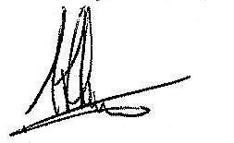
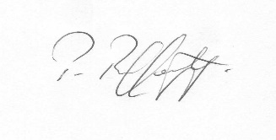
Fiona Harper  The Secretary | Pat Rafferty  For UNITE the Union | Alick Smith  For SELECT

