SJIB Circular 01/2022
28 January 2022

To: All SJIB and SELECT Members

Dear Sir/Madam,

Temporary Change to SSP Self-Certification Evidence

The UK Government has announced a temporary change to the Statutory Sick Pay (Medical Evidence) Regulations 1985 to support the coronavirus booster programme.

Any employees who have been absent from work due to an illness that began on or after 17 December up to and including 26 January 2022 will not be required to provide their employers with medical evidence of sickness for 28 days for the purposes of Statutory Sick Pay (SSP).

This is a temporary but significant change and employers should make it clear that that normal company absence reporting procedures will continue.

If employees are self-isolating and are unable to work because of coronavirus (COVID-19) they can get an isolation note from NHS 111. They do not have to go to their GP or attend a hospital.

We will advise you of any further changes in due course.

Members wishing further information should email natalie.burke@select.org.uk
or fiona.cornwall@sjib.org.uk

Yours faithfully,
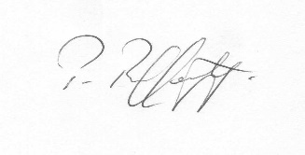
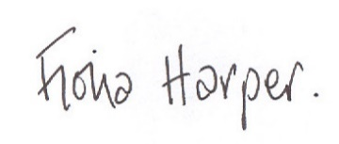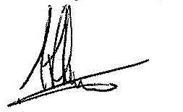
Fiona Harper Pat Rafferty Alick Smith
The Secretary For UNITE the Union For SELECT

