SJIB Circular 03/2022
28 January 2022

To: All SJIB and SELECT Members

Dear Sir/Madam,

National Minimum Wage (NMW) and National Living Wage (NLW) Rates

The Government has announced that the National Living Wage (NLW) and National Minimum Wage (NMW) rates will increase on 1 April 2022.

Age | Pay per hour
23 and over | £9.50 (NLW)
21 to 22 | £9.18
18 to 20 | £6.83
16 to 17 | £4.81
Apprentice | £4.81

There is no need to take any further action for Operatives, Apprentices and Adult Trainees who are paid in accordance with the SJIB National Working Rules. Furthermore, the SJIB has agreed contractual rates which Electrical Installation Apprentices should be paid and which can be viewed here.

However, please note that Stage 2 Apprentices who are aged between 21 and 22 should be paid in accordance with the NMW rates above, Stage 2 Apprentices who are aged 23 and over should be paid the NLW rate and Stage 3 Apprentices who are aged 23 and over should be paid the NLW rate when at college.

If you employ any operatives and staff under other terms and conditions, we recommend that you ensure the hourly rates meet the minimum rates.

Members wishing further information should email fiona.cornwall@sjib.org.uk or
natalie.burke@select.org.uk

Yours faithfully,
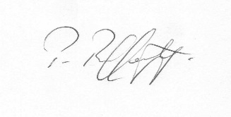
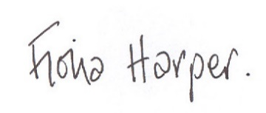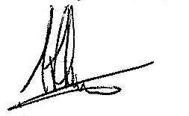
Fiona Harper Pat Rafferty Alick Smith
The Secretary For UNITE the Union For SELECT

